West Mercia Police
Hereford Rural North
Safer Neighbourhood Team (SNT)
herefordrn.snt@westmercia.pnn.police.uk
May 2014

About your team

Safer Neighbourhood Teams work with local people and partners to identify, tackle and solve issues that matter to the community where you live.
Making neighbourhoods safer by cutting day to day crime and anti-social behaviour is at the heart of keeping people in West Mercia safe. Thanks to an investment in mobile tablet style computers, these will enable officers to spend more time on patrol on the street and in neighbourhoods.
Officers will continue to come to people when they need them and provide a high quality service however you contact us - in person (on the street, at community bases and at partners and communities together [PACT] meetings), on the phone or online.

Your team
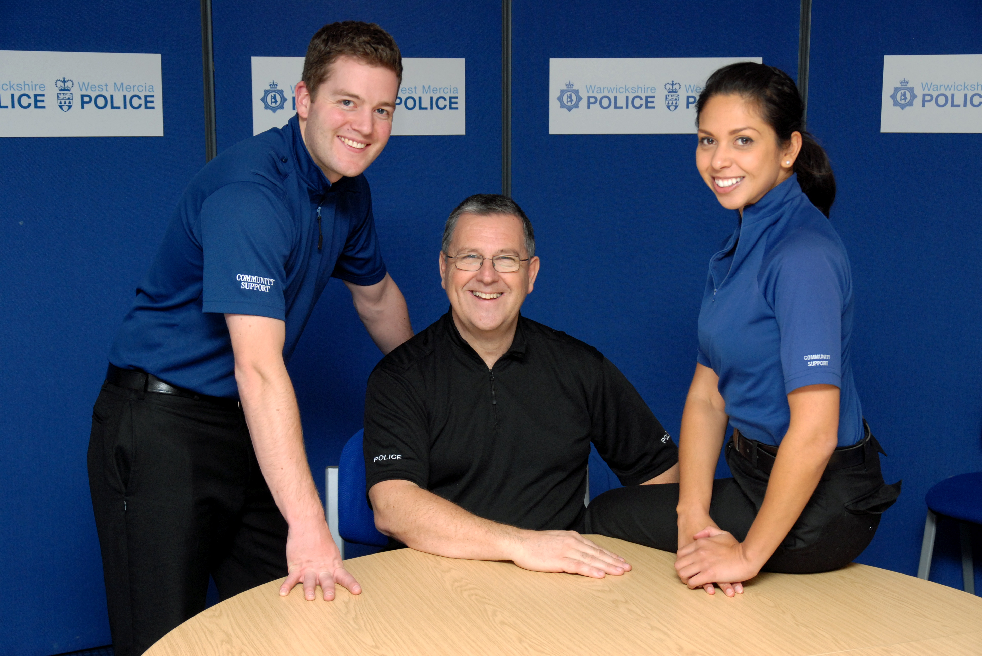
PCSO Dean WALL – PC Neil JAMES – PCSO Elena EKANITE

Where we work
Members of the Hereford Rural North Safer Neighbourhood Team are based at Bath Street, Hereford. We work in the Wards of:-
Backbury (Checkley, Dormington, Hampton Bishop, Fownhope, Stoke Edith, Shucknall, Tarrington and Weston Beggard)
Burghill (Burghill, Holmer, Munstone, Pipe cum Lyde, Shelwick and Tillington)
Credenhill (Breinton, Credenhill and Stretton Sugwas)
Hagley (Bartestree, Lugwardine, Preston Wynne, Westhide and Withington)
Sutton Walls (Marden, Moreton on Lugg and Sutton St Nicholas) and
Wormsley Ridge (Bishopstone, Bridge Sollars, Bush Bank, Byford, Canon Pyon, Dinmore, Kenchester, Kings Pyon, Ledgemoor, Mansel Lacy, Mansel Gamage, Yasor, Yarsop, Wellington and Westhope and Wormsley)

Get in touch
 101 to talk to your local SNT/report a crime
 herefordrn.snt@westmercia.pnn.police.uk
✓ www.westmercia.police.uk

/ @HerefordCops
Only call 999 in an emergency, when a crime is in progress or life is in danger.

Update

Crimes of interest from 1st April – 30th April 2014

Credenhill
During the early hours of 09/04/2014 persons unknown have entered a victim’s driveway and taken milk and orange juice from the doorstep. This has occurred on multiple occasions over the past month.

A caravan was broken into in the village of Credenhill at some point between 15/12/2013 and 08/04/2014. Offenders forced entry to the caravan and stole a quantity of hand tools and a small 14” DVD/TV.

Whilst patrolling on 14/04/2014 a PCSO drove into Credenhill park woods. The Officer approached a vehicle to speak to the occupants and has immediately smelt a strong smell of cannabis. The four occupants have then been searched by MOD/WMP officers. One male was cautioned for the possession of Cannabis and a passenger was given a street warning.

Stretton Sugwas
Between 22:00-22:30 on 11/04/2014 Unknown offenders have cut a barbed wire fence and entered the grounds of a local business in the village. Offenders were disturbed whilst trying to steal bag filled with plant pots. Police were passed a description of a male in dark clothing possibly driving a Vauxhall Astra.

Mordiford
On 09/04/2014 at 23:45 a male parked in a secluded area of Mordiford was caught smoking cannabis; he was issued with a cannabis warning. (This is a low level disposal method for first time offenders.)

Holmer and Shelwick
A push bike has been stolen from an insecure garden shed in the Holmer area. This occurred during the hours of darkness on 07/04/2014.

Bartestree
On Tuesday 08th April 2014 a local resident’s works van was stolen off the driveway, this occurred at 14:00. The vehicle was later tracked and found by Police and returned to keeper.

Cross Keys
At some point between 04/04/2014-07/04/2014 Offenders have stolen two life size cast iron statues of deers from outside a premise in the Cross Keys area.

Breinton
On Sunday 13/04/2014 at 19:17 police were conducting a mobile patrol of the Breinton area. Police became suspicious of two youths who were sat in a stationary vehicle. Upon approaching the vehicle the police could smell a strong aroma of cannabis coming from the vehicle. Upon searching the vehicle an amount of cannabis was found.

Withington
On Monday 07/04/2014 between 00:01-23:59 unknown offenders have caused damage to the flood lights located on play area next to the village hall. The glass was smashed on three of the lights.

Mansel Lacy
Between Monday 07/04/2014 00:01 and Wednesday 09/04/2014 16:00 person unknown have entered farm yard which has an open entry to the front and have approached a secure workshop and have used unknown implement to cut off the padlock to the door. Entry has been gained to the workshop and a pressure washer stolen from within.

Checkley
Between Wednesday 16/04/2014 22:00 and Thursday 17/04/2014 09:00 a property located in the remote area of Checkley has been targeted by offenders. Offenders climbed through an outbuildings window and stole a red/silver lawn flight strimmer.

Swainshill
On Saturday 12/04/2014 at 20:41 a popular restaurant located in the Swainshill area was broken into, Offenders climbed the roof and broke a window to gain entry. Nothing was stolen; it is believed the onsite alarm scared them off.

Stoke Edith
At some point between Thursday 17/04/2014 16:00 and Saturday 19/04/2014 11:00 Unknown offender(s) have approached the main gate and used unknown implement to cut off the padlock. Entry gained to the site. Offender(s) have then approached a storage container and again cut through the padlock to gain entry and steal a compressor. An additional padlock has been cut off the main cap of a double bunded diesel tank and approximately 200 litres of red diesel has been syphoned off and stolen.

Fownhope
On Thursday 17/04/2014 at 16:00 Offenders have stolen power tools from a secured shed; the shed was located in a very rural location within Fownhope.

Canon Pyon
Copper piping has been stolen from a disused farm cottage in Canon Pyon, Hereford. This occurred between Friday 25/04/2014 16:00 and Monday 28/04/2014 09:30.

Westhide
On Friday 17th April an address in Westhide was searched for drugs, the warrant was positive and the occupant was arrested for possession of cannabis.

Sutton St Nicholas
Between Wednesday 23rd April and Thursday 24th April persons unknown have approached a domestic oil storage tank situated on the driveway of a property which is situated in a no-through lane in a rural area. The offenders have unscrewed the insecure cap on the oil tank and using an unknown implement have syphoned approximately 500 litres of oil from out of the tank.

Woolhope
On Wednesday 23rd April person(s) unknown have entered rear garden to rural dwelling premises where the garden was insecure. Padlocks have been broken off shed door to gain entry, once inside have removed power tools

If you have any information regarding the above incidents please contact the Police on 101. Thank you.

Parking Outside Schools

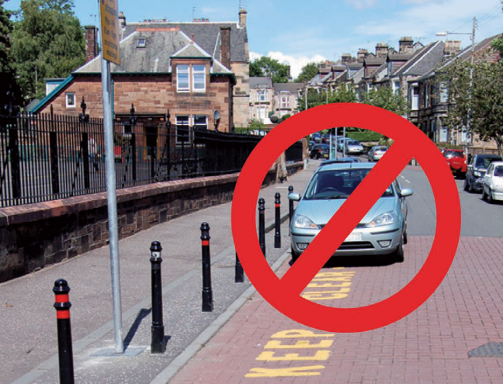

All parking restrictions outside schools are there for the safety of pupils, pedestrians and staff – not for the driver’s convenience

We have received complaints about parking outside a number of our local schools. We understand that many parents need to use their cars to drop their children at school. However, please park responsibly

- If possible, park away from the school and walk the rest of the way
- Ensure your parking does not cause any inconvenience to anyone else
- Do not park illegally: Do not park or drive on the pavements and do not park on double yellow lines or yellow zig zag lines
- Causing an obstruction in any manner listed above could result in a Fixed Penalty Notice of £30



Come Along and Meet the Team!
Members of the Safer Neighbourhood Team hold surgeries at various locations throughout the Hereford Rural North policing areas. This is a great opportunity to meet the team. We are happy to discuss any concerns and offer advice on anything from security to anti-social behaviour. We often have lots of useful leaflets and information for you to take home.
* Future surgeries are at the following locations:
- Wormsley Golf Club on 04/05/2014 @ 14:00.
- Queenswood Garden Centre on 12/05/2014 @ 14:00.
- Hereford Cattle Market on 14/05/2014 @ 11:00.
- Fownhope Leisure Centre on 25/05/2014 @ 12:00.
* The SNT will make every effort to attend Parish Council meetings and surgeries at the advertised time, however, please note that there may be unforeseen incidents where their involvement is required. Please refer to the Get in Touch details if you require further contact from the team.

More useful numbers/contact details

Mobiles:
PC James 07974 818920
PCSO Wall 07970 602443
PCSO Ekanite 07816 172518

Crimestoppers 0800 555 111
Victim Support 01432 347208
Childline 0800 1111
Domestic Violence Helpline 0800 7831359
National Drugs Helpline 0800 776600
National NHW Association 02079 630160
Herefordshire Road Safety
Hotline 01432 364582
Herefordshire NHW:
www.communicate.co.uk/here/hfdsneiwatch/

